Understanding The Functionality of the “System:Admin” Role
Table of Contents
OVERVIEW/REQUESTING THE “SYSTEM:ADMIN” ROLE . . . . . . . . . . . . . . . . . . Pg.2
“SYSTEM:ADMIN” FEATURES . . . . . . . . . . . . . . . . . . Pg.4
PENDING ROLE REQUESTS . . . . . . . . . . . . . . . . . . Pg.5
ASSIGNING ROLES . . . . . . . . . . . . . . . . . . Pg.6
ADDING USERS . . . . . . . . . . . . . . . . . . Pg.9
MANAGING (EDITING/DESTROYING) EXISTING GROUPS . . . . . . . . . . . . . . . . . . Pg.11
CREATING NEW GROUPS . . . . . . . . . . . . . . . . . . Pg.16
BATCH USERS . . . . . . . . . . . . . . . . . . Pg.19

The “System:Admin” role is a unique role within the TxPHIN portal that provides designated users with administrative functionality that does not appear in the role’s absence. Users who are assigned this role have the tools to approve roles within their jurisdiction(s), assign roles, create new user profiles, manage groups, and add multiple users to the PHIN portal through batch upload.
REQUESTING THE “SYSTEM:ADMIN” ROLE
As a registered TxPHIN user, you will be directly assigned the role of “System:Admin” by the Texas Department of State Health Services (DSHS). To determine if you have already been assigned the role, login to your profile at TxPhin.org and click the “My Account” tab in the top right-hand navigation panel of your dashboard.
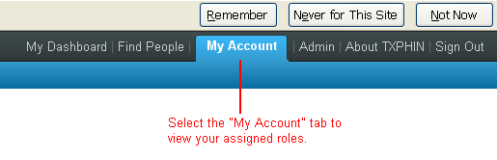

If the role has been assigned to you, it will appear under the “Roles” section of your “My Account” page.
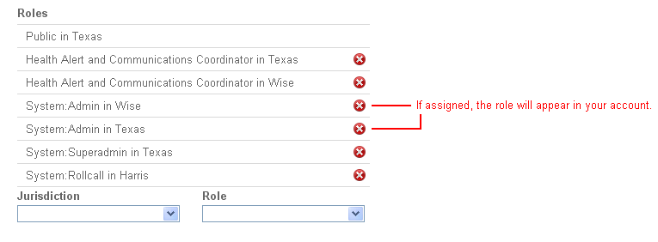
If the role does not appear, you will need to request it by emailing phinadmin@dshs.state.tx.us. After the request is reviewed by DSHS, it will either be approved or denied.

“SYSTEM:ADMIN” FEATURES
As a “System:Admin” in your jurisdiction, you will be able to see an “Admin” tab that appears in the upper right hand corner of your navigation panel. Once selected, this tab allows you to view the following pages:
- Pending Role Requests
- Assign Roles
- Add a User
- Manage Groups
- Batch Users
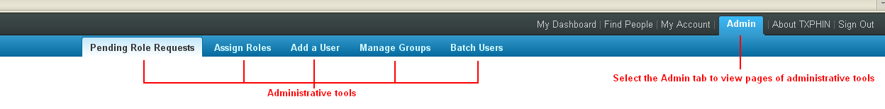

PENDING ROLE REQUESTS
A registered user in your jurisdiction(s) will submit a role request from his or her TxPHIN account that will appear on your “Pending Role Requests” page. A pending request will show a registered user’s email address, desired role, and jurisdiction giving you the option to approve or deny the role directly from this page by clicking “Approve” or “Deny”. If you need to know more about a user before approving or denying his or her role request, simply click on the email address in the request and the user’s profile will appear. Click the back button in your browser to return to the Pending Role Requests page.
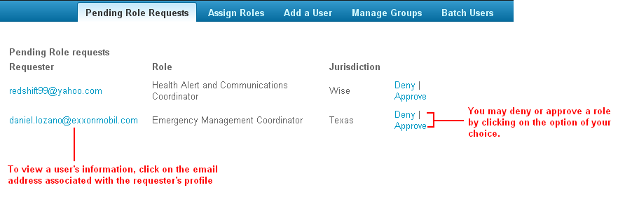

ASSIGNING ROLES
As a “System:Admin” you can assign roles to registered users in your jurisdiction(s). Select the “Admin” tab from your TxPHIN Dashboard and click on the “Assign Roles” tab. In the field titled “People” begin typing the name of the person to whom you wish to designate a role. As you begin typing a name you will see real-time results that allow you to either select the name from a filtered list or finish typing the name.
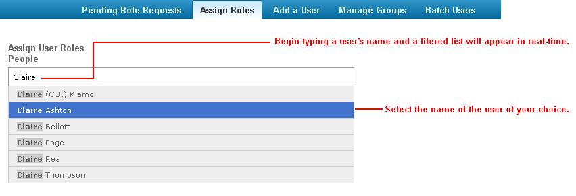
Once selected, the name should appear in a blue box in the “People” field. If you decide you no longer wish to assign a role to a user in the “People” field, click the “X” on the right side of the blue box to delete your selection. After you have chosen a user, select the jurisdiction and role that you wish to assign. Clicking the “Assign Roles” button at the bottom of the screen will finalize the entry and assign the role to the user.
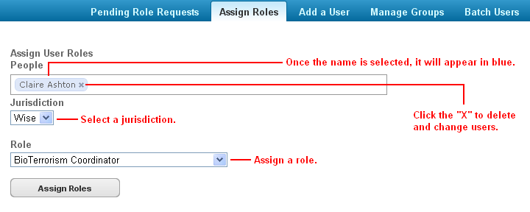
You may also assign roles to a user directly from his or her profile. To assign roles this way you must navigate away from the “Admin” tab and select the “Find People” tab. Once selected, you can enter a user’s name or email address in the “Search for” field and a list of suggested users will appear. Click on the name of the user to whom you wish to designate a role.
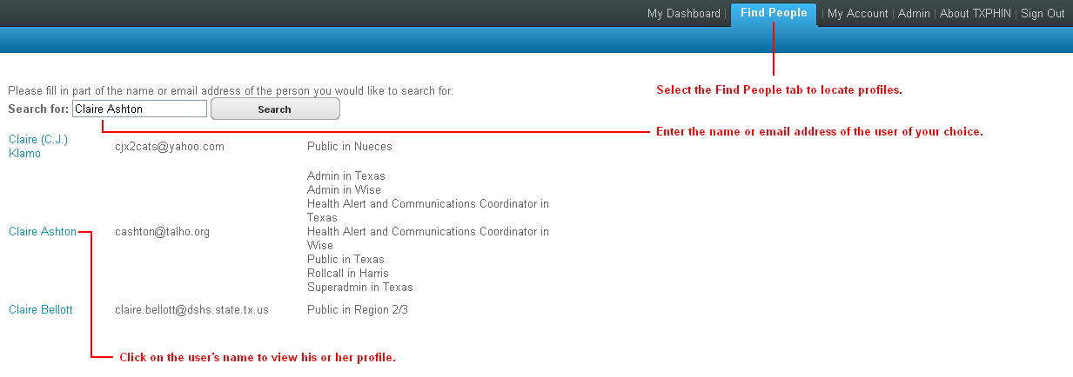
From the selected user’s profile, click the “Edit this Person” button at the bottom of the page. If the user who you selected is not from your jurisdiction then you will receive an access restriction warning that says “You are not authorized to edit this profile”. If you do have authorization to access the profile, clicking the “Edit this Person” button will expand the user’s profile to allow you to edit all fields. Scroll down the user’s profile to the “Roles” section where you will see both a list of roles that are already assigned and a pull-down menu that allows you to assign new roles. To assign a new role, select the appropriate jurisdiction and role from the pull-down menu and click the “Save” button at the bottom of the profile.
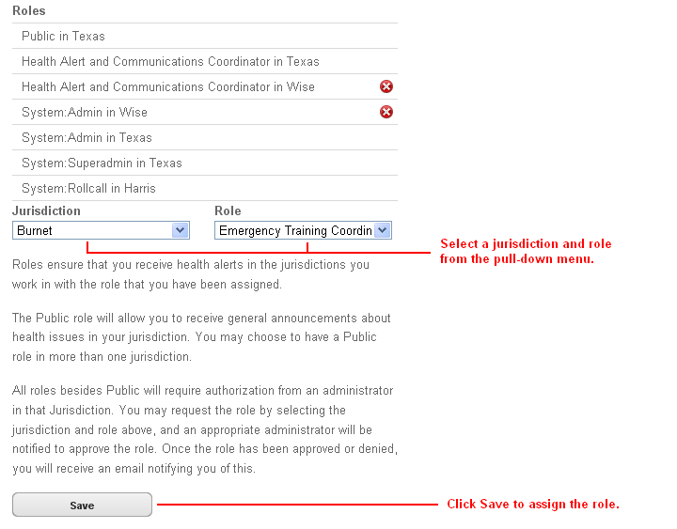
ADDING USERS
As a “System:Admin” you are able to create user profiles for people who are not already registered TxPHIN users. First, navigate to the “Admin” tab. From there, select the “Add a User” tab. A “New user” page will appear prompting you to fill in the following fields:
- First Name
- Last Name
- Preferred name to be displayed
- Email address
- Password / Password Confirmation
- Preferred language
- Job title
- County or DSHS Health Service Region
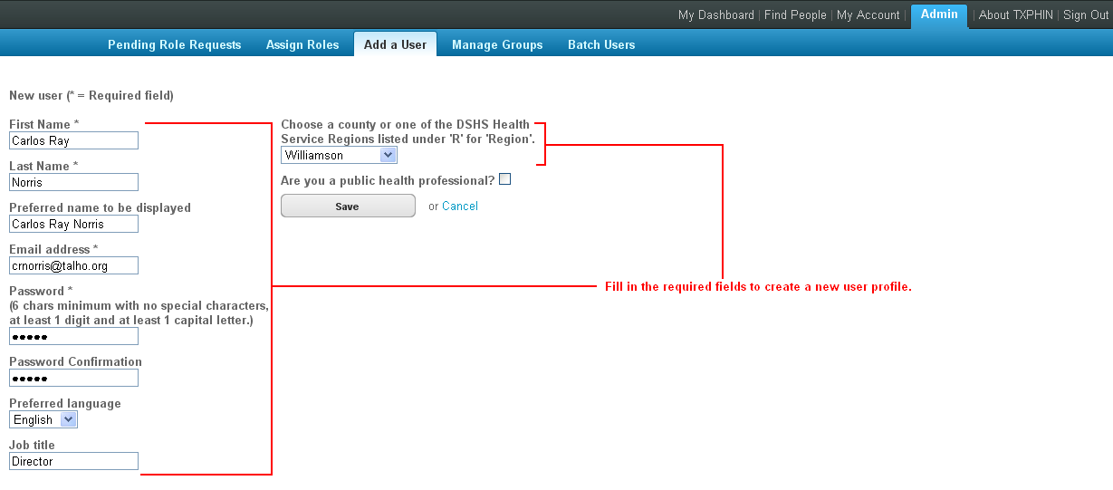
In the new user form, there is an optional checkbox next to the question “Are you a public health professional?” If checked, two pull-down menus will appear; one asking you to list the primary role of the new user in public health or emergency response and two, a list of organizations to which the new user may be affiliated. Select the appropriate choices from the pull-down menus and click the “Save” button to create the profile. If all fields have been entered correctly, you will see a confirmation in yellow that says “This user has been successfully created”.
[Note: when entering passwords for a new user, you must use at least 1 digit, 1 capital letter, and a minimum of 6 characters.]
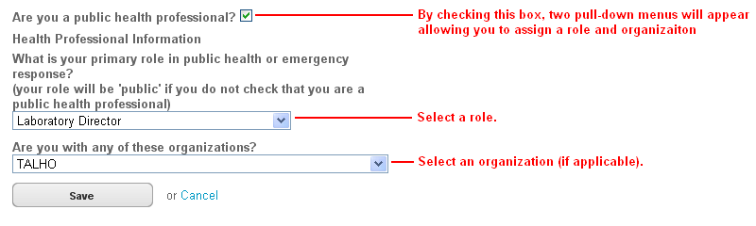

MANAGING EXISTING GROUPS
If you are a “System:Admin” you have access to the tools to manage existing groups. First, navigate to the “Admin” tab. From there, select the “Manage Groups” tab. A list of groups will appear with the following indentifying information:
- Name (group title)
- Owner (user who created the group)
- Scope (access to the group)
In order to locate a group, you can sort the list by clicking on the column title “Name”, “Owner”, or “Scope”. By clicking on the column titled “Name”, for example, the list will be sorted alphabetically by name, from A-Z. Clicking on the column titled “Name” a second time will reverse the alphabetized list to read from Z-A.
Use the “Previous” and “Next” arrows at the bottom of the screen to skip from one page to the next.
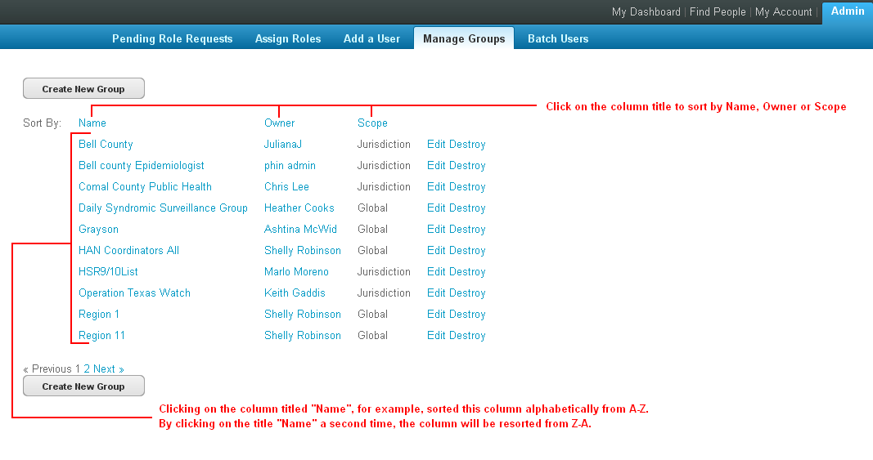
All groups are designated as one of the following:
- Personal
- Jurisdiction
- Global
As a general rule, a “System:Admin” can edit or destroy any group that he or she creates. Otherwise, the following designations have the following permissions:
Personal
Only the group’s creator can edit or destroy a group designated as “Personal”.
Jurisdiction
A group designated as “Jurisdiction” can be edited or destroyed by any “System:Admin” within the jurisdiction where the group originated.
Global
Any “System:Admin” can edit or destroy a “Global” group.
To edit a group, simply click on the “Edit” button located on the right side of the group name to expand your selection. If you have permission to edit the group, then the Jurisdictions, Roles, and People who have previously been assigned to the group will appear. From this screen, you may delete existing group members or add new Jurisdictions, Roles, and People.
To add Jurisdictions or Roles, check the box next to the Jurisdiction or Role of your choice. To delete Jurisdictions or Roles, uncheck the box next to the Jurisdiction or Role of your choice.
To add People, type the name of the user you wish to add in the “Add” field at the bottom of the page. As you type, a filtered list will begin to appear in real-time, allowing you to either completely type the user’s name or select them from the list of possible choices. To delete a person, mouse over their name and a circle with a red “X” will appear. Click the “X” as the user will be deleted from the group.
Click the “Save” button at the bottom of your page to save your edit.
To delete a group, click the “Delete” button located on the right side of the group name. A dialog box will appear asking you to confirm you selection. Click “Ok” to destroy the group or “Cancel” to maintain the group and return to the previous screen.
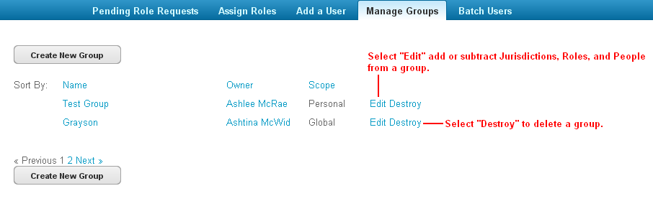
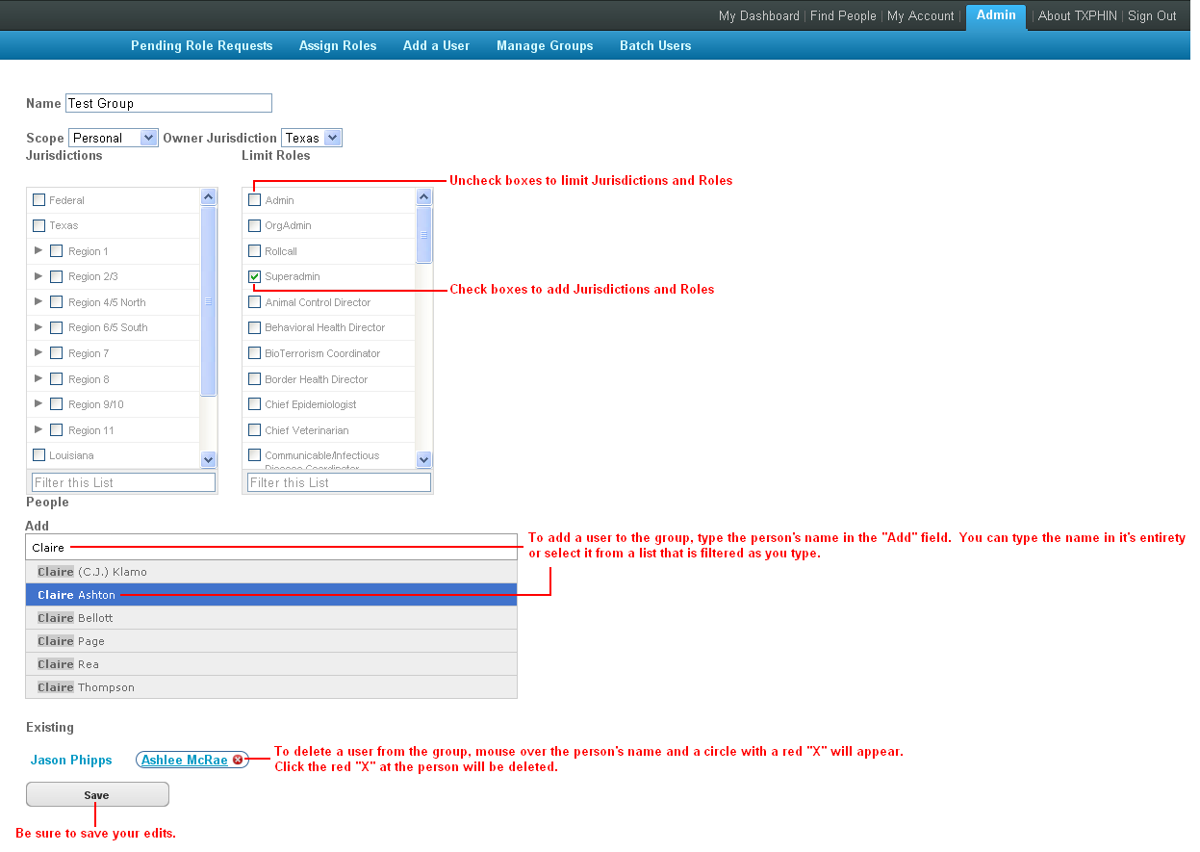
CREATING NEW GROUPS
A user with a “System:Admin” role has the ability to create a new group by first navigating to the “Admin” tab and then the “Manage Groups” tab. From there, click the “Create New Group” button.
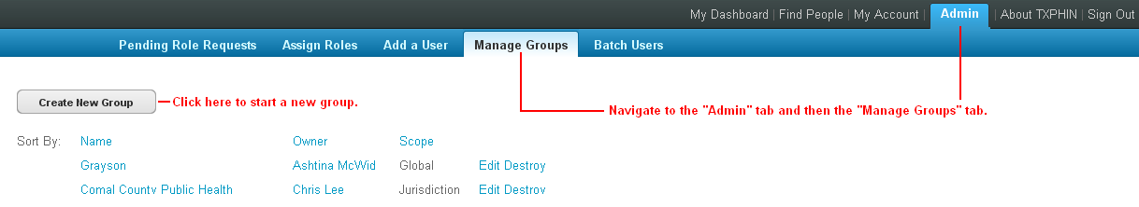
A form will appear prompting you to enter a name of your group in the “Name” field. Select the “Scope” of your group from the pull-down menu that includes the choices Personal, Jurisdiction, or Global. Then, choose the originating jurisdiction for the group from the pull-down menu.
You can now begin adding Jurisdictions, Roles, and People (individual users) to your group. To add a Jurisdiction or Role, check the box next to the selection of your choice. For ease of use, you may type the name of the Jurisdiction or Role in the “Filter this List” box at the bottom of each column. As you type, you will see real-time results.
To add individuals to the group, type the name of the user you wish to add in the “Add” field at the bottom of the page. As you type, a filtered list will begin to appear in real-time, allowing you to either completely type the user’s name or select them from the list of possible choices.
Be sure to save your edits by clicking the “Save” button at the bottom of the page when you are finished.
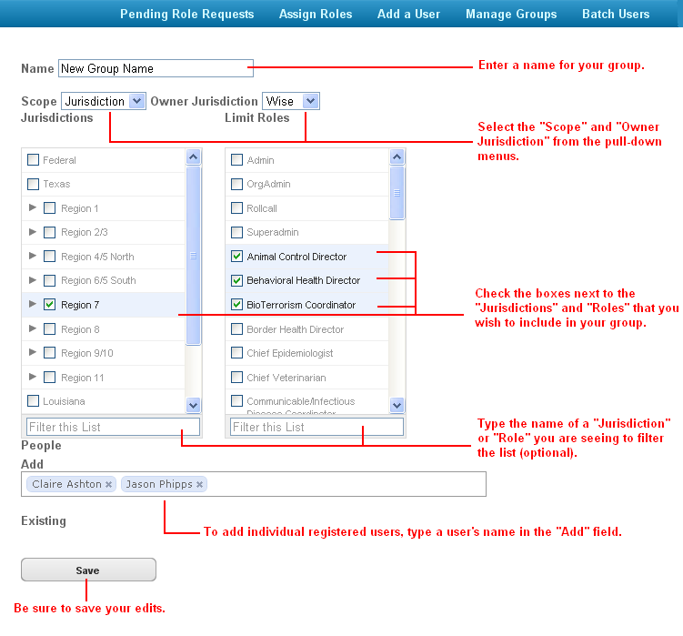
If you are trying to create a group within a single county or counties, you must be sure to leave the region checkbox unchecked. Click on the arrow to the left of the Region affiliated with the desired county you wish to add. By doing so, a subcategory of counties will appear. Check the county of your choice.
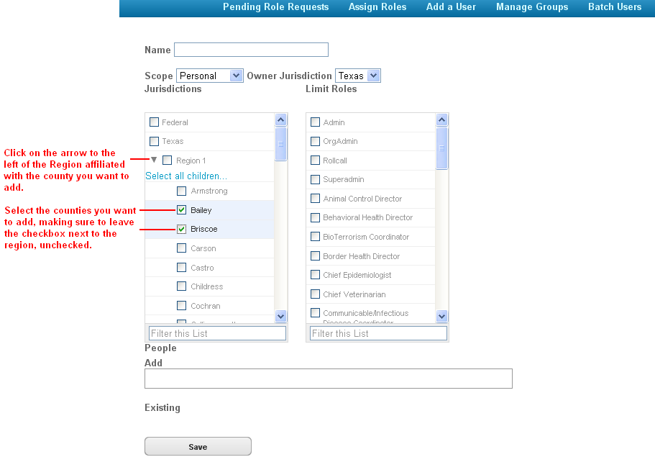

BATCH USERS
A “System:Admin” has access to the “Batch” tab; a page where CSV (comma separated value) files containing specific information fields can be uploaded to create profiles for multiple users. In order to upload multiple users at a time, you must first make sure your CSV file is formatted correctly.
To create the correct type of file for upload, open an Excel file and enter the following categories separated by a “comma” or a “pipe” into Column A, Row 1.
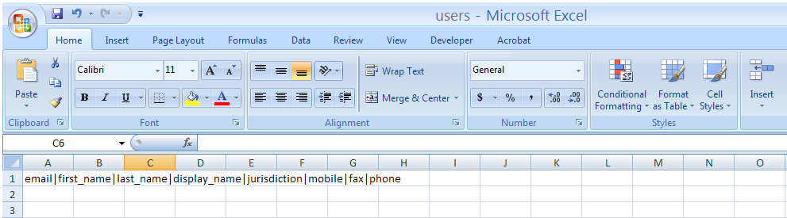

The success of your upload is dependent on the category order. Include, in this order:
- Email address (required)
- First Name (required)
- Last Name (required)
- Display Name (required)
- Jurisdiction (required)
- Mobile (optional)
- Fax (optional)
- Phone (optional)

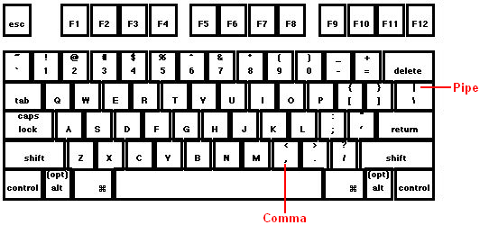
“Required” fields contain information that must be present in order to create a new user. “Optional” fields contain user information that you may or may not have. To insure that your CSV file is uploaded properly, please include the space for an “optional” field, separated by a comma or pipe. Although the format is required in order to upload, “Optional” fields may be left blank.
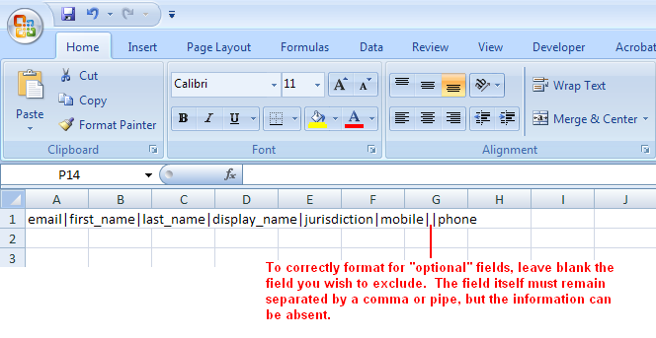
Navigate to the “Admin” page and select the “Batch Users” tab. Because all users are required to have a jurisdiction associated with their profiles, you will be prompted to select a “default jurisdiction”. Only approved jurisdictions assigned to your profile will appear in this field.
Click the “Browse” button, locate your file, and select it. Click “Upload” to complete the process.
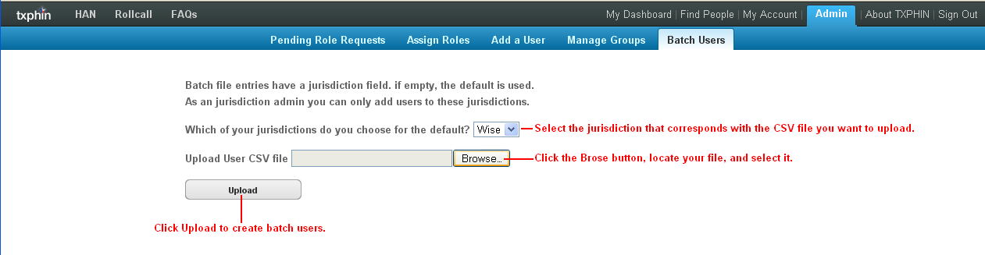
(NOTE: You can only upload your file once since a Display Name (user name) will already be in use on a second try. Each CSV file that you upload may contain users in only one jurisdiction. Do not mix multiple jurisdictions into one file).

